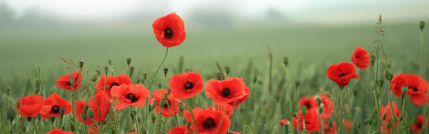

POPPY APPEAL COFFEE MORNING 2015

LADY RICKETTS, wife of H.M. Ambassador to France

Has kindly accepted to host a Coffee Morning

In aid of the Poppy Appeal

Which the ROYAL BRITISH LEGION, PARIS BRANCH

Organizes every year for the benefit of the

EARL HAIG BENEVOLENT FUND

The Coffee Morning will take place at

THE BRITISH AMBASSADOR’S RESIDENCE

39 rue du Faubourg St. Honoré,

Paris 8eme

TUESDAY, 3rd NOVEMBER 2015

10h30 - 12h00

Please send your stamped addressed envelope to :

Mrs Janet Warby
5 Allée des Pins,
78480 Verneuil sur Seine
01 39 28 90 28 or roger.warby@wanadoo.fr
PLEASE PRINT YOUR NAMES IN CAPITAL LETTERS

An invitation card for presentation at the entrance will be sent to you. This is a Charity event, please give generously. All donations welcome. I.D. Cards or Passports required. Numbers are limited. Date limit for applications 28/10/2015

